Assignment – 10
Alias
- Write a query to display EMPLOYEE_ID as ID, FIRST_NAME as First, and LAST_NAME as Last from the employees table.
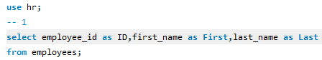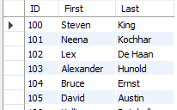
- Write a query to display JOB_ID as JobCode, JOB_TITLE as Title, and MIN_SALARY as MinimumSalary from the jobs table.
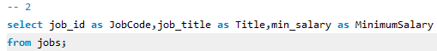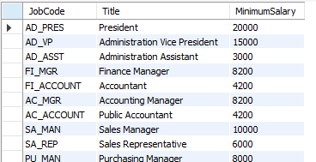
- Write a query to display the FIRST_NAME and LAST_NAME of employees from the employees table by using an alias e for the table.
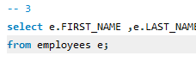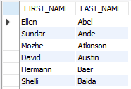
- Write a query to display the EMPLOYEE_ID and the full name (FIRST_NAME + ' ' + LAST_NAME as FullName) of employees, and sort the result by FullName in descending order.
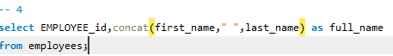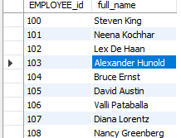
- Write a query to display EMPLOYEE_ID as ID, FIRST_NAME as Name, and SALARY as Income from the employees table for employees with a salary greater than 5000, using aliases for the columns.
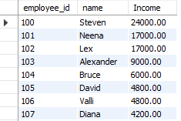
Do it after joining:

- Write a query to display the EMPLOYEE_ID, FIRST_NAME, and DEPARTMENT_NAME from the employees and departments tables using aliases e for employees and d for departments.
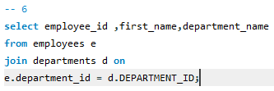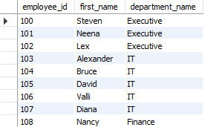

- Write a query to display COUNTRY_NAME and REGION_NAME from the countries and regions tables, using aliases c for countries and r for regions, where the REGION_ID is greater than 2
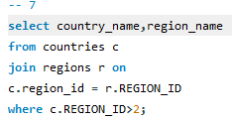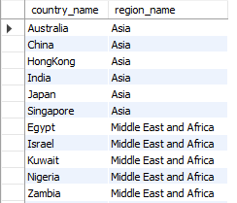

- Write a query to display the FIRST_NAME and LAST_NAME of employees whose department name is "IT", using aliases e for employees and d for departments.
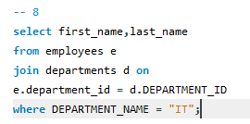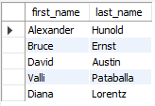
- Write a query to display the average salary (AVG(SALARY) as AverageSalary) for each department using aliases for the departments and employees tables.
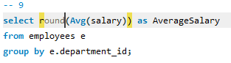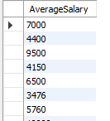
- Write a query to display the REGION_NAME and the total number of countries in each region (as CountryCount), using aliases for both the countries and regions tables
